Hedda PAhlson-MOller
TIIME (www.tiime.org)

19 Rue Du Nord, L-2299 Luxembourg, LUXEMBOURG
Mob Lux:[352]621 515 745 Email: heddapm@OMSINT.com
D.O.B. 5/5/75 (Quebec, Canada) Citizenship: Sweden (EU); Canada

Hedda Pahlson-Moller, co-founder of TIIME (Social Impact Catalyst), is a Business Angel, Impact Investor, Adjunct Professor, Board member and public speaker.

The common denominator of her endeavors is mobilizing capital and resources towards positive social and environmental impact, leveraging the power of diversity and entrepreneurship.

Topics: Social Impact / Impact Economy / Social Innovation / Social Entrepreneurship / Impact Investing / Venture Philanthropy / entrepreneurial thinking /early-stage investing / business angels / Gender-Lens Investing / financial early stage ventures / Diversity as alpha

Cover article of National Paper (in French):
https://www.wort.lu/de/business/portrait-d-un-entrepreneur-responsable-hedda-business-angel-58b436bca5e74263e13ab390#
In English: http://www.eban.org/portrait-responsible-entrepreneur-hedda-business-angel
On Impact investing: http://www.mynewsdesk.com/no/ferd-se/pressreleases/social-impact-investing-how-to-get-started-2203292
On Social Entrepreneurship: http://www.mynewsdesk.com/no/ferd-se/news/is-social-entrepreneurship-norways-new-export-255826

Speaking engagements
https://www.tiime.org/achievements
https://www.linkedin.com/in/hedda-pahlson-moller-95b11a/

upcoming 2019
- Oct – Philanthropy conf sweden
- Oct – SHU
- Oct - SESI
- Sept 26 - CFA Institute, Germany

2019

Horizon Impact Award – Chair of jury https://ec.europa.eu/info/research-and-innovation/funding/funding-opportunities/prizes/horizon-impact-award_en
July 15

ILA Essentials ‘Sustainability’ and Board Simulation, July 10-12

TIIME ‘#ImpactImperative training: demystifying Sustainabilty’ July 3-4

INSEAD Panel discussion paradigm Shift in Governing Sustainabilty (Role of Boards in Sustainabilty)
https://www.insead.edu/centres/corporate-governance/towards-sustainability-a-new-curriculum-for-boards#Programme-009274, April 8-9

“ReThink your Clothes’ – Moderator and Interview of Guest speaker, March 8, 2019

2018 Completed

- Commencement Speech, Sacred heart University Graduation 2018, Dec 14
- Panel “Inclusivity and Impact” and ‘Practioners perspective’ at the 17th International Entrepreneurship Forum (IEF): north-South: the emergent, transformational axes of opportunity development, Nancy, France, Dec 12-14 http://ieforums.org/the-conference-schedule
- Video contribution “who made my clothes’ Caritas FILM: RETHINK YOUR CLOTHES, Dec 11: https://www.facebook.com/rethinkyourclothes/videos/572584593188560/
- UBS GLobal Philanthropy Forum, St Moritz, Swizerland, Nov 30-Dec 1
- Keynote Interview, ILA (Institute of Independent Directors) Annual Event: Climate Change for board Rooms, Luxembourg, Nov 29 https://ila.lu/event/ila-directors-day-2018-11-29-3215/agenda
- Moderation of climate migration conference at BGL BNP Paribas,, Nov 28 https://www.lmdf.lu/en/private-investors/events/climate-migration-event/
- Moderation: New investment Theories in Gender-Lens Investing, LONDON, Nov 1-2 https://www.gendersmartinvesting.com/tools-and-learning-3
- SILICON Luxembourg INTERVIEW: 15 years of start-up Life in Luxembourg, Oct 19 https://www.siliconluxembourg.lu/startup-apero-a-continued-success/
- Opening panel and Keynote on ‘Democratization of impact investing’, EBAN Winter university, Luxembourg http://www.eban.org/better-together-eban-winter-summit-2018
https://drive.google.com/drive/u/0/folders/1O2QtKFuRYApb5ZGebI72b5tYtgjhSCp6
- “Build Something That Matters” BITS & PRETZELS, tech conference, Munich, Germany https://www.bitsandpretzels.com/speakers ; https://www.bitsandpretzels.com/agenda#item-details-itemid_35 - PHOTO
- Design and Delivery (Moderation) of TIIME Stone Soup conference on Impact Management – Barcelona, Sept 27/28, 2018 www.3sconference.ORG ; https://vimeo.com/273861698
- Design, Hosting and moderation of the LMDF/VDL impact ecosystem event:
https://www.lmdf.lu/en/private-investors/more-information/impact-ecosystem-event-2018/
- Panel “How can we scale the impact opportunity in wealth management?” Fund Forum International June 12, https://finance.knect365.com/fundforum-international/speakers/hedda-pahlson-moller
- Event Moderation of TRANSEO SME conference, Luxembourg May 17-18
- Equilibre Annual event - Celebration of Gender Complementarity http://www.hrone.lu/actualites/equilibre-fete-son-1er-anniversaire
- Impact finance fundraising Training Module for Climate Finance Accelerator – ICFA, Luxembourg http://www.luxembourg.public.lu/en/actualites/2017/06/28-climate-finance/index.html -
- Keynote “Landscape of Impact Investing and Trends of the Impact Economy” and Panel for Luxembourg Private Equity Association (LPEA) event https://www.lpea.lu/2018/03/22/lpea-pre-insights-impact-investing-summary/ - March 22
- Panel member ALFI European Asset Management conference: Sustainable Investing and Climate Finance –https://events.alfi.lu/speakers-information-page-eam18/ March 6/7
http://delano.lu/d/detail/news/alfi-conference-preview-investing-instead-giving/171233
- Moderating EBAN Impact webinar with jochen Vermouth “The Winners and Losers in the Green Economy” –https://i0c5g.mailupclient.com/f/rnl.aspx/?nme=ry4f&hk=v5.h-=xzps2-g3-c=bh8d&x=pp&w3&x=pv&45e8ie&NCLM March 5
- Keynote at the WBAF (World Business Angel Forum) “The Rise of Impact Investing” – Istanbul – (presentation: https://www.youtube.com/watch?v=KNVR4fihnhI&feature=youtu.be) Feb 20
- Jury for Vodafone F-Lane Accelerator, Berlin, http://www.f-lane.com/about/ (Advisory) - Feb 12
- “What is Impact” lecture for a MOOC (Massive Open Online Course) for Social Entrepreneurship Academy on EDX.com, Munich (Launch June 201), Feb 5
- Moderating Fireside chat with SuperAngel Dusan LBAN Annual Event: Demystifying Angel Investing https://www.siliconluxembourg.lu/calendar/lban-annual-event-demystifying-angel-investing/, Feb 4
- Head of Jury, Woman Innovator Prize, European Commission, Brussels, Jan 30/31 https://ec.europa.eu/research/prizes/women-innovators/index.cfm?pg=home
- FERD Social accelerator Launch and Training: Value Proposition and Business Models, Oslo, SOCENTRAL http://www.socialstartup.no, Jan 17

2017 Completed

- Speaker and Jury, UBS Philanthropy Forum, Dec 8-10, St Moritz, Switzerland
- Toniic end of year – Dec 5, London
- Catalyst At Large & TIIME strategy session, Dec 4, London
- SHU Soc E-ship course
- ILA Director’s Day Annual Conference, ‘Why Risk is a non-Financial Matter: turning Risk into Opportunity” Dec 11 http://ila.lu/en/news-press-room-detail/news/directors-day-2017-why-risk-is-non-financial-matter-turning-risks-into-opportunities/
- Event Designer & Master of Ceremonies: evpa conference, Nov 8-10, Oslo, Norway https://evpa.eu.com/annual-conference/conference-checkpoint-committee
https://www.facebook.com/EVPAupdates/photos/a.243342142864840.1073741835.154353818430340/246577675874620/?type=3&theater
- FERD Social Entrepreneurship training, Nov 7, Oslo, Norway https://www.tiime.org/single-post/2017/11/29/TIIME-crazy-week-in-Oslo-–-8-10-November-2017
- Opening Moderator for Conference, Panel moderator (Tech for Good) EBAN conference, Oct 16-17, Munich
- Jury Member, ‘Social Entrepreneur of the year’, Ferd, Oslo Norway https://sosentkonferansen.no/ase/jury/
- Keynote and Jury Member ‘Unleash – SDG Innovation Lab’ Aarhus, Denmark Aug 17-19 https://unleash.org
- Keynote and Moderator “The Impact Ecosystem’ LMDF and Ville De Luxembourg, July 11 https://www.lmdf.lu/en/private-investors/events/2017-the-impact-ecosystem/
- Keynote “Niche no more: Impact Imperative” EBAN conference, Malaga, June 8 http://ebanmalaga2017.com/speakers/
- Moderator ‘Women Entrepreneurs and Women Investor Networks’ EBAN conference, Malaga, June 8 http://ebanmalaga2017.com/annual-congress-agenda-7-9-june/
- Interview Silicon Luxembourg on the past/present/Future of Social Impact in Luxembourg, May 30th https://issuu.com/siliconluxembourg/docs/silicon_06 (p30-33)
- Lunch and Learn about Entrepreneurial thinking to create Internal Change at Banque International Luxembourg HQ, May 29
- Presenter at Sacred Heart University ‘power knowledge morning’, Luxembourg: “Niche no more: the emergence of social e-ship and the impact economy, May 13 https://www.facebook.com/events/270703600066640/permalink/278867365916930/?ref_newsfeed_story_type=regular&action_history=[%7B%22surface%22%3A%22newsfeed%22%2C%22mechanism%22%3A%22feed_story%22%2C%22extra_data%22%3A[]%7D]
- futurepreneurs, Lithuania, May 3 http://futurepreneurs.eu https://www.facebook.com/events/224743501328227/
- Jury to SNJ Youth Prize, March 22 http://r.search.yahoo.com/_ylt=A0LEVwnNpj5Zm.AA1_5XNyoA;_ylu=X3oDMTEybnNqNnFiBGNvbG8DYmYxBHBvcwM5BHZ0aWQDQjQwNzlfMQRzZWMDc3I-/RV=2/RE=1497306958/RO=10/RU=http%3a%2f%2fdownload.rtl.lu%2f2017%2f05%2f19%2f3f0f75845afcde96f128b5e003856dad.pdf/RK=1/RS=hiZ0HBy1ZFk1NIeA1I3PnMwrzUE-
- Investor/Jury Contributor to the F-Lane Vodafone Accelerator, Berlin, March 16
http://www.f-lane.com/team/hedda-pahlson-moller/
- Keynote Speaker – Global Entrepreneurship Network conference in South Africa: Business Angels and Impact Investing, March 14-16 Johannesburg
- Keynote Speaker and master of ceremony “Women Effect: Gender lens investing @ BIL (Int’l womens Day):, March 8 http://www.lmdf.lu/en/private-investors/events/the-women-effect-invest-differently-2017/
- Presenter of EBAN impact webinar on social Investing: featuring FASE and GSEN, March 1
- Wort Article (Cover and Feature profile), Feb 28 http://www.eban.org/portrait-responsible-entrepreneur-hedda-business-angel
- Master of Ceremony, LBAN Annual event & GA ‘Demystefying Business Angels’ at BCEE, Feb 27 https://www.siliconluxembourg.lu/calendar/lban-annual-event-demystifying-angel-investing/
- Launch of EQUILIBRE @ Atelier: http://paperjam.lu/news/pour-un-juste-equilibre-des-genres?utm_medium=email&utm_campaign=23-02-2017-soir&utm_source=Email%20marketing%20software , Feb 24,
- Press Conference with the Secretary of State on gender complementarity think tank ‘Equilibre’ RTL link http://tele.rtl.lu/emissiounen/de-journal/3081527.html (min 17) Feb 9th
- Leading workshop on “learning from Failure’ at the LCSB (Luxembourg Center for systems Biomedecine ) Jan 25
- Case Study on ‘Impact Metrics’ training for 123Go Social, @ NYUKO (Led by Cecile Sevrain), Jan 25
- Presenter of the European Commission Woman innovator award’ at the UN Convention, Brussels http://www.tiimeisnow.org/single-post/2017/02/06/EU-Prize-for-Women-Innovators , Jan 24
- Jan 23-24 - Head of Jury, European Commission ‘Woman Innovator Award’ #WIP2017 http://ec.europa.eu/research/index.cfm?pg=newsalert&year=2016&na=na-130916

2016
- Presentation for the CSDD ‘Social Responsible Investment’, MDDI, Dec 21, 2016 http://www.csdd.public.lu/fr/conseil/annuaire/hedda_pahlson.html
- Head of Jury, European Commission ‘Woman Innovator Award’ Application Review: http://ec.europa.eu/research/index.cfm?pg=newsalert&year=2016&na=na-130916
- Advisory Board, Vodafone F-Lane, Berlin Dec 15, 2016 http://www.f-lane.com/about/
- KeyNote Speaker @ EBAN Winter University Zagreb ‘The Impact Imperative – earn your wings, Business Angels’. Nov 28-30, 2016 http://ebanwu2016.com/hedda-pahlson-moller/
http://www.eban.org/eban-winter-university-zagreb-2016-breaks-mold-record-numbers-world-class-speakers-investors-entrepreneurs
- Organizer, Moderator and Keynote for PWC Social Innovation Symposium Nov 15, 2016 http://www.pwc.lu/en/events/pwc-social-innovation-symposium.html
- Opening and Moderation from EVPA Annual Conference, Nov 3,4
- Moderator for ADA ‘Creating Social Fintech for Microfinance’ (Oct 18, 2016, Casino Luxembourg) http://www.ada-microfinance.org/en/our-projects/digital-finance/creating-social-fintech-for-microfinance
- SESI ‘Towards sustainable business models’ (Oct 17 Uni Lux)
- Country Branding Oct 11, 2016 http://www.wort.lu/en/business/nation-branding-new-logo-promo-for-luxembourg-57fcaf255061e01abe83a244
  - http://paperjam.lu/rendez-vous/un-budget-et-une-identite-pour-le-pays
- DnB training for private banking ‘motivation, sales strategies and entrepreneurial approach (Oct 8, 2016)
- Friendship Charity dinner – Moderation of ‘Beyond Capital” Oct 7, 2016
- Capital Impact: Amsterdam (Sept 28, 2016Keynote/Panel ‘Capitalize Imact: talks and Panel discussion’ http://capitalweek.amsterdam/session/capital-impact/
- EBAN Impact webinar, Sept 27
- LBAN training ‘introduction to business angel activities’ sept 26, 2016
- eRevalue D&I Webinar “Equal Opportunity Reality: Diversity and Inclusion – Who Runs the World?”(July 23, 2016) https://vimeo.com/177711161
Speakers: • Hedda Pahlson-Moller, CEO OMSINT/TIIME • Kimberly Davis, Senior Managing Director and Head of Corporate Responsibility and Inclusive Leadership Practice, Teneo Holdings • Evan Harvey, Director Corporate Responsibility, NASDAQ OMX; Chair of World Federation of Exchanges Sustainability Working Group
- ADA training ‘Entrepreneurial mindset and Business model generation’
- MOOC (massive open onlne course) : http://globalsummerschool.org/mooc/ “Access to finance for Social entrepreneurs’ – 11,000 registrations worldwide
- EBAN Impact webinar ‘impact measurement’ June 28, 2016
- Master of Ceremony & Keynote Speaker “what does Social Entrepreneurship mean?” 123GoSocial (Feb 16, 2016) https://nyuko.lu/evenement/soiree-de-cloture-123-social/
- Master of Ceremony “Demystifying Angel Investing” LBAN & BIL joint event (Feb 1, 2016) http://www.eban.org/wp-content/uploads/2016/02/le-monde-est-petit.pdf
- Lecture @ University of Luxembourg Masters of Wealth Management “The Principles of Venture Philanthropy” (Jan 22, 2016)
- Keynote Speaker & Workshop leader, SEIF Congress on Impact Investing: Zurich, Switzerland (Jan 19, 2016) http://seif.org/de_DE/congress/

2015
** South africa Entrepeneurship conference
- moderator Boosting Social Enterprises in Europe (December 3-4, 2015) http://www.eu2015lu.eu/en/agenda/2015/12/03-04-conf-economie-sociale/03-04-Boosting-social-enterprises-in-Europe-draft-programm.pdf
- master of ceremony and organizer of the EIB Investor Fair (December 3, 2015) http://institute.eib.org/programmes/social/investors-fair-2015/
- Master of Ceremony and Overall Coordinator | EVPA Annual Conference 2015 (December 1-2, 2015) http://evpa.eu.com/annual-conference-2015/highlights/
- Master of Ceremony: | 6th European Microfinance Award (November 19, 2015) http://www.european-microfinance-award.com
- Keynote @ EBAN Winter University, Copenhagen “True Value Creation through Impact Investing” (Nov 17, 2015)
- Lecture: University of Luxembourg, SESI (Social Enterprise & Social Innovation” program “when social innovation meets busines models” (Oct 20, 2015)
- Moderator bgl bnp Paribas Open: “unexpected secrets for success in business and sports” interview with Mirjana Lucic, Alioune Touré and isabelle sainte-antoine (October 19, 2015)
- European Investment Bank “The Bank in context: New Entrepreneurs – Investments and Perspectives”: “Entrepreneurship as a mindset” (October 19, 2015)
- October 1-2, 2015: Keynote Speaker: Venture Philanthropy & Social Investment – a model for Malta? | EVPA Event Malta
- *Keynote & panel moderator, 14th IEF Conference, South Africa 2015 (September 16-18, 2015)
- *Moderator: ‘Is Impact Investing the next Venture Capital?), Global Shapers Conference, Frankfurt (bloomberg) | The Next B2B Forum: Disrupt for Impact 2015 (September 10, 2015)
- *Master of Ceremony: ‘Celebrating Social Entrepreneurship and social Investing in Luxembourg’ 123GoSocial, Banque du Luxembourg, March 12, 2015 http://www.123gosocial.lu/fr/vid%C3%A9o-de-l%C3%A9v%C3%A9nement-123-go-social-du-12-mars-2015
  - Trainer: 123Go Social pitch training

2014
- Coordinator: European Venture Philanthropy Annual conference, Berlin (Nov 17-18, 2014)
- *Speaker: World Investment Forum, United Nations, Geneva “Business Schools for Impact” (Oct 13-16, ‘14)
  - Video: https://vimeo.com/110894153
- Lecture: University of Luxembourg, SESI (Social Enterprise & Social Innovation” program “Making Ends Meet: Business Models” (Oct 14, 2014)
- Moderator BGL BNP Paribas ‘Star Athletes as entrepreneurial role models’ Interview with Daniela Hantuchova (Oct 13, 2014)
  - video: https://vimeo.com/109797289 (focus: @3 min)
- Moderator: Introducing the Leaders of Social Innovation: ASHOKA @ the Impactory (June 18, 2014) http://theimpactory.com/events/ashoka-comes-to-the-impactory/
- Keynote Speaker: Sabanci University, Social Investment Program, Istanbul, Turkey (June 2, 2014), https://www.eventbrite.com/e/su-social-investment-program-reception-with-hedda-pahlson-moller-eban-tickets-11651980387
- Jury Member: Start-Up Weekend Luxembourg, technoport (May 25, 2014) http://luxembourg.startupweekend.org/
- Speaker: KPMG Private Equity Team Presentation on Responsible Investing and Social Impact (May 21, 2014)http://www.kpmg.com/LU/en/IssuesAndInsights/Articlespublications/Pages/PrivateEquityMookeditionSpringSummer2013.aspx
- Moderator: EBAN annual Conference, Dublin, Ireland ‘Impact Investing’ (may 19, 2014) http://www.ebancongress2014.org/programme.html
- Speaker: EIB INSTITUTE: Fourth meeting of the Social Platform (May 15, 2014) http://institute.eib.org/wp-content/uploads/2014/06/03_MT_SOCIAL_PLATFORM_ENTREPRENEURSHIP_BRO_8P_EN1.pdf

2013
- Lecture: University of Luxembourg Doctoral Program (October 23, 2013): “Social Entrepreneurship and Impact Investing”
- Speaker: EIIL launch – New Legal Structures in Luxembourg for Social Impact, Panel Discussion, September 26, 2013) Le Luxembourg à la pointe de l’économie sociale, http://innovationsociale.lu/sites/default/files/DocumentEIIL.pdf
- Interview: Frank Peter’s Show (JULY, 2013): http://thefrankpetersshow.com/2013/luxembourgs-hedda-pahlson-moller/
- Training: National Research Fund (AFR) Entrepreneurship Training for Doctoral Students (June 2013) http://fnr.lu/en/News-Events/News/AFR-Networking-Day-21-June-2013-From-Skills-to-Careers
- Speaker: Impact Economy ‘Symposium and Retreat 2013’ “Business Angels in Impact Investing” (June, 2013) Switzerland/Austria http://symposium2013.impacteconomy.com/event/speakers/2013/hedda-pahlson-moller
- Training: European Business Angel Network Congress “ Impact Investing 101”, (May, 2013 – Vienna) http://www.amiando.com/EBAN2013.html?page=944566
- Lecture: University of Luxembourg Business Plan Competition: “Business Model Gen” (June, 2013)
- Jury Member: Start-up weekend, Technoport: (May, 2013) http://luxembourg.startupweekend.org/
- Moderator: Federation des jeunes dirigentes ‘Entrepreneurial landscape in Luxembourg’ (May 2013)
- Moderator: Club of Amsterdam, ‘The Future of Impact Investing’, (March, 2013, Amsterdam) http://www.clubofamsterdam.com/event.asp?contentid=878
- training: Impactory Lecture Series: Business Model Canvasing and sales techniques (Feb, March 2013)
http://theimpactory.com/events/business-model-canvas-workshop/#.Uji4j2Q-KSw
- Speaker: Ferd Conference on Social Entrepreneurship (Feb 13, 2013), Oslo, Norwayhttp://www.kongehuset.no/binfil/download2.php?tid=119693
- Moderator: Luxembourg Business Mentoring & Luxembourg Institute for Global financial integrity “Corporate social responsibility Roundtable” (sept 2012)
- Keynoted speaker: JCI Creative young Entrepreneur of the Year (CYEL) Award: Philharmonic, Luxembourg (July, 2009) http://www.jcluxembourg.com/CYEL.html

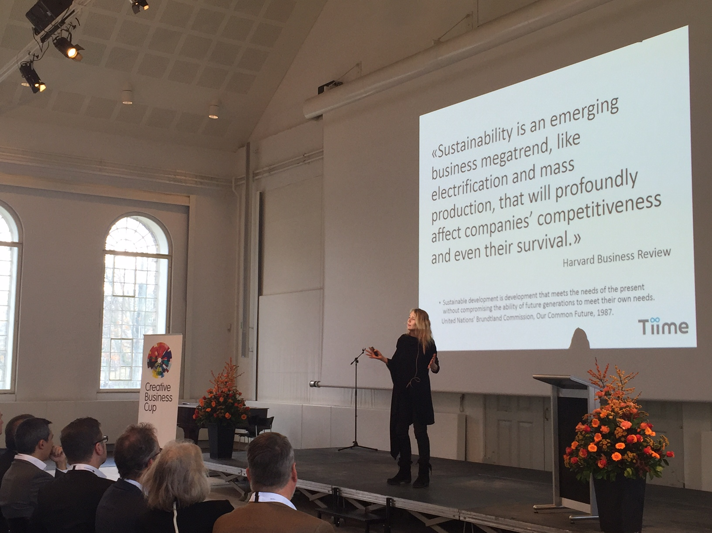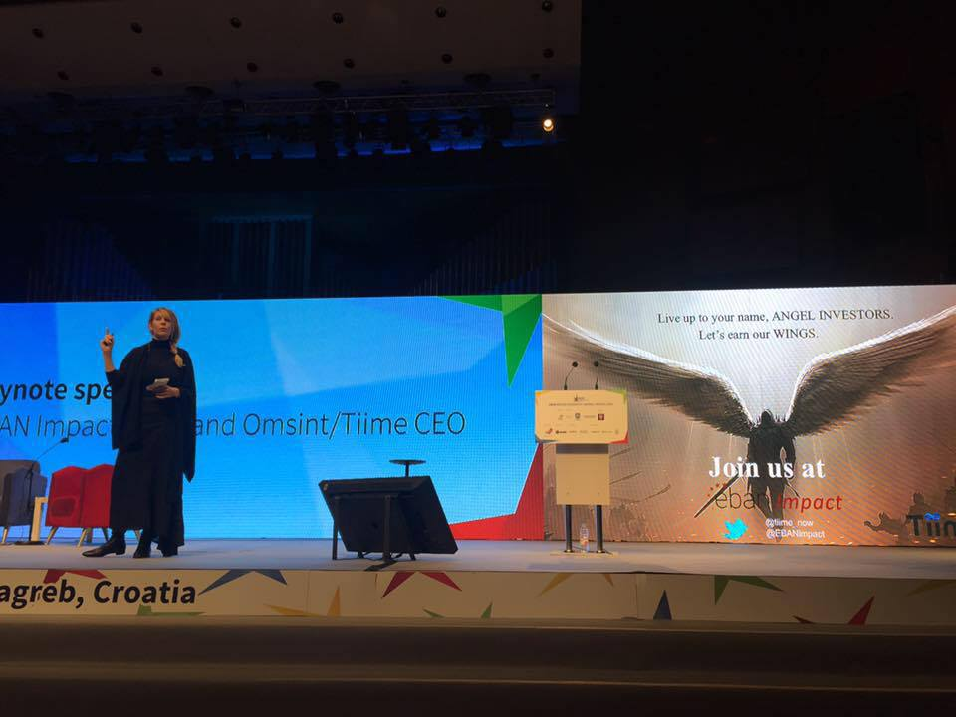
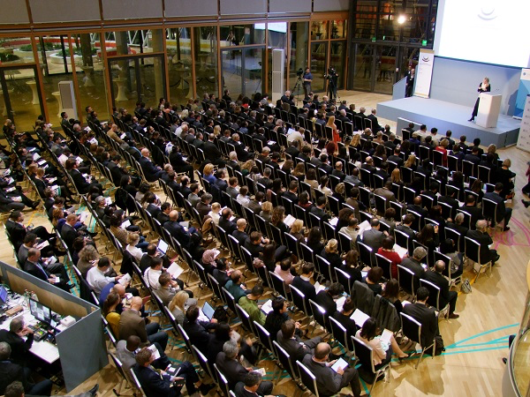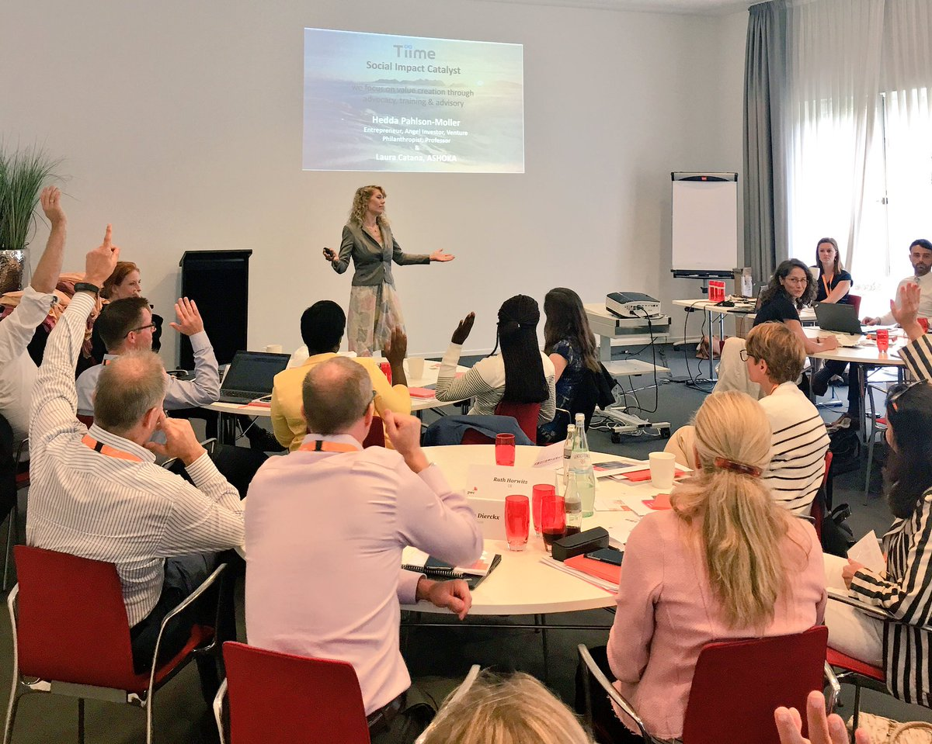

Press Coverage
https://docs.wixstatic.com/ugd/3318db_7923fa9e6acd4712a4beae904e524f17.pdf

